a
01.09 Powerplants (Engine/APU)
Process Design & AMOS Configuration Document
Purpose
This Process Design document is provided to Key-Users to record their key decisions regarding the AMOS Process design and the required AMOS configuration.
It is updated throughout the Project Definition Phase and used as the baseline for the Final Acceptance prior to Go-Live
Revision
Author, Name | Date | Notes
Pradeep Pathirana | 29.May 2024 | 1. version
Jakub Sadowski | 1. June 2025 | New Flowchart (visio version) included

Table of Contents
1. Process Overview & Objectives 3
2. Definitions & Glossary 3
3. Process Tasks 4
4. Process Dependencies 4
5. Process Flow 5
6. Process Design Questions 6
7. Data (Source) Mapping 7
8. Other Software Used 7
9. AMOS Configuration 8
a. Basic Data 8
b. Parameters 8
c. Workflows 8
d. API’s & Interfaces 9
10. UAT Guidance 9
11. Annex – Additional Info 9

Process Overview & Objectives

Process General Description:
This process enables the operator to record the oil uplifts and Oil Consumption Statistics and define, track the Powerplant alerts, investigate, and report relevant Powerplant events to further investigate and report to the authority.

Main Process Objectives:
- Oil Consumption Statistics
Oil uplifting data are entered via Flightlog/ Workorder into AMOS and the engineering department can define the alerts and monitor for the exceedance.

- Engine Condition Monitoring
Engineering department can set the alert levels per PN according to OEM, Authority or Airline recommendations to monitor the trend of performance of units and systems.

- IFSD Tracking
To maintain ETOPS certification, the operator must systematically monitor and report any instances of in-flight shutdowns (IFSDs). Event Tracking and Powerplant Event Administration are used for recording and investigating IFSDs. These inputs could be used to generate the reports in IFSD tracking.

- Powerplant Event Administration
Engineers can track power plant events with Powerplant Event Administration. Furthermore, it enables users to link and monitor all expenses associated with Powerplant events.

- Powerplant Administration
Powerplant Administration can be used to record the basic data of engines and APUs and can be customized by using “customisable Panel editor”.

Definitions & Glossary

Key-Words | Explanation
ETOPS | Extended Twin engine Operation System
IFSD | Inflight Shutdown
NEF | Non-essential Equipment and Furnishings

Process Tasks

Business Process Task / Actions / Activities:
- Set the Trend Values per PN
- Define the Oil Consumption alter levels.
- Create Power plant event.
- Maintain general information of Engine per Part number.
- Create IFSD reports.

Process Dependencies

- 06.02 Delays & Event Tracking
- 08.02 Performing Maintenance

Process Flow
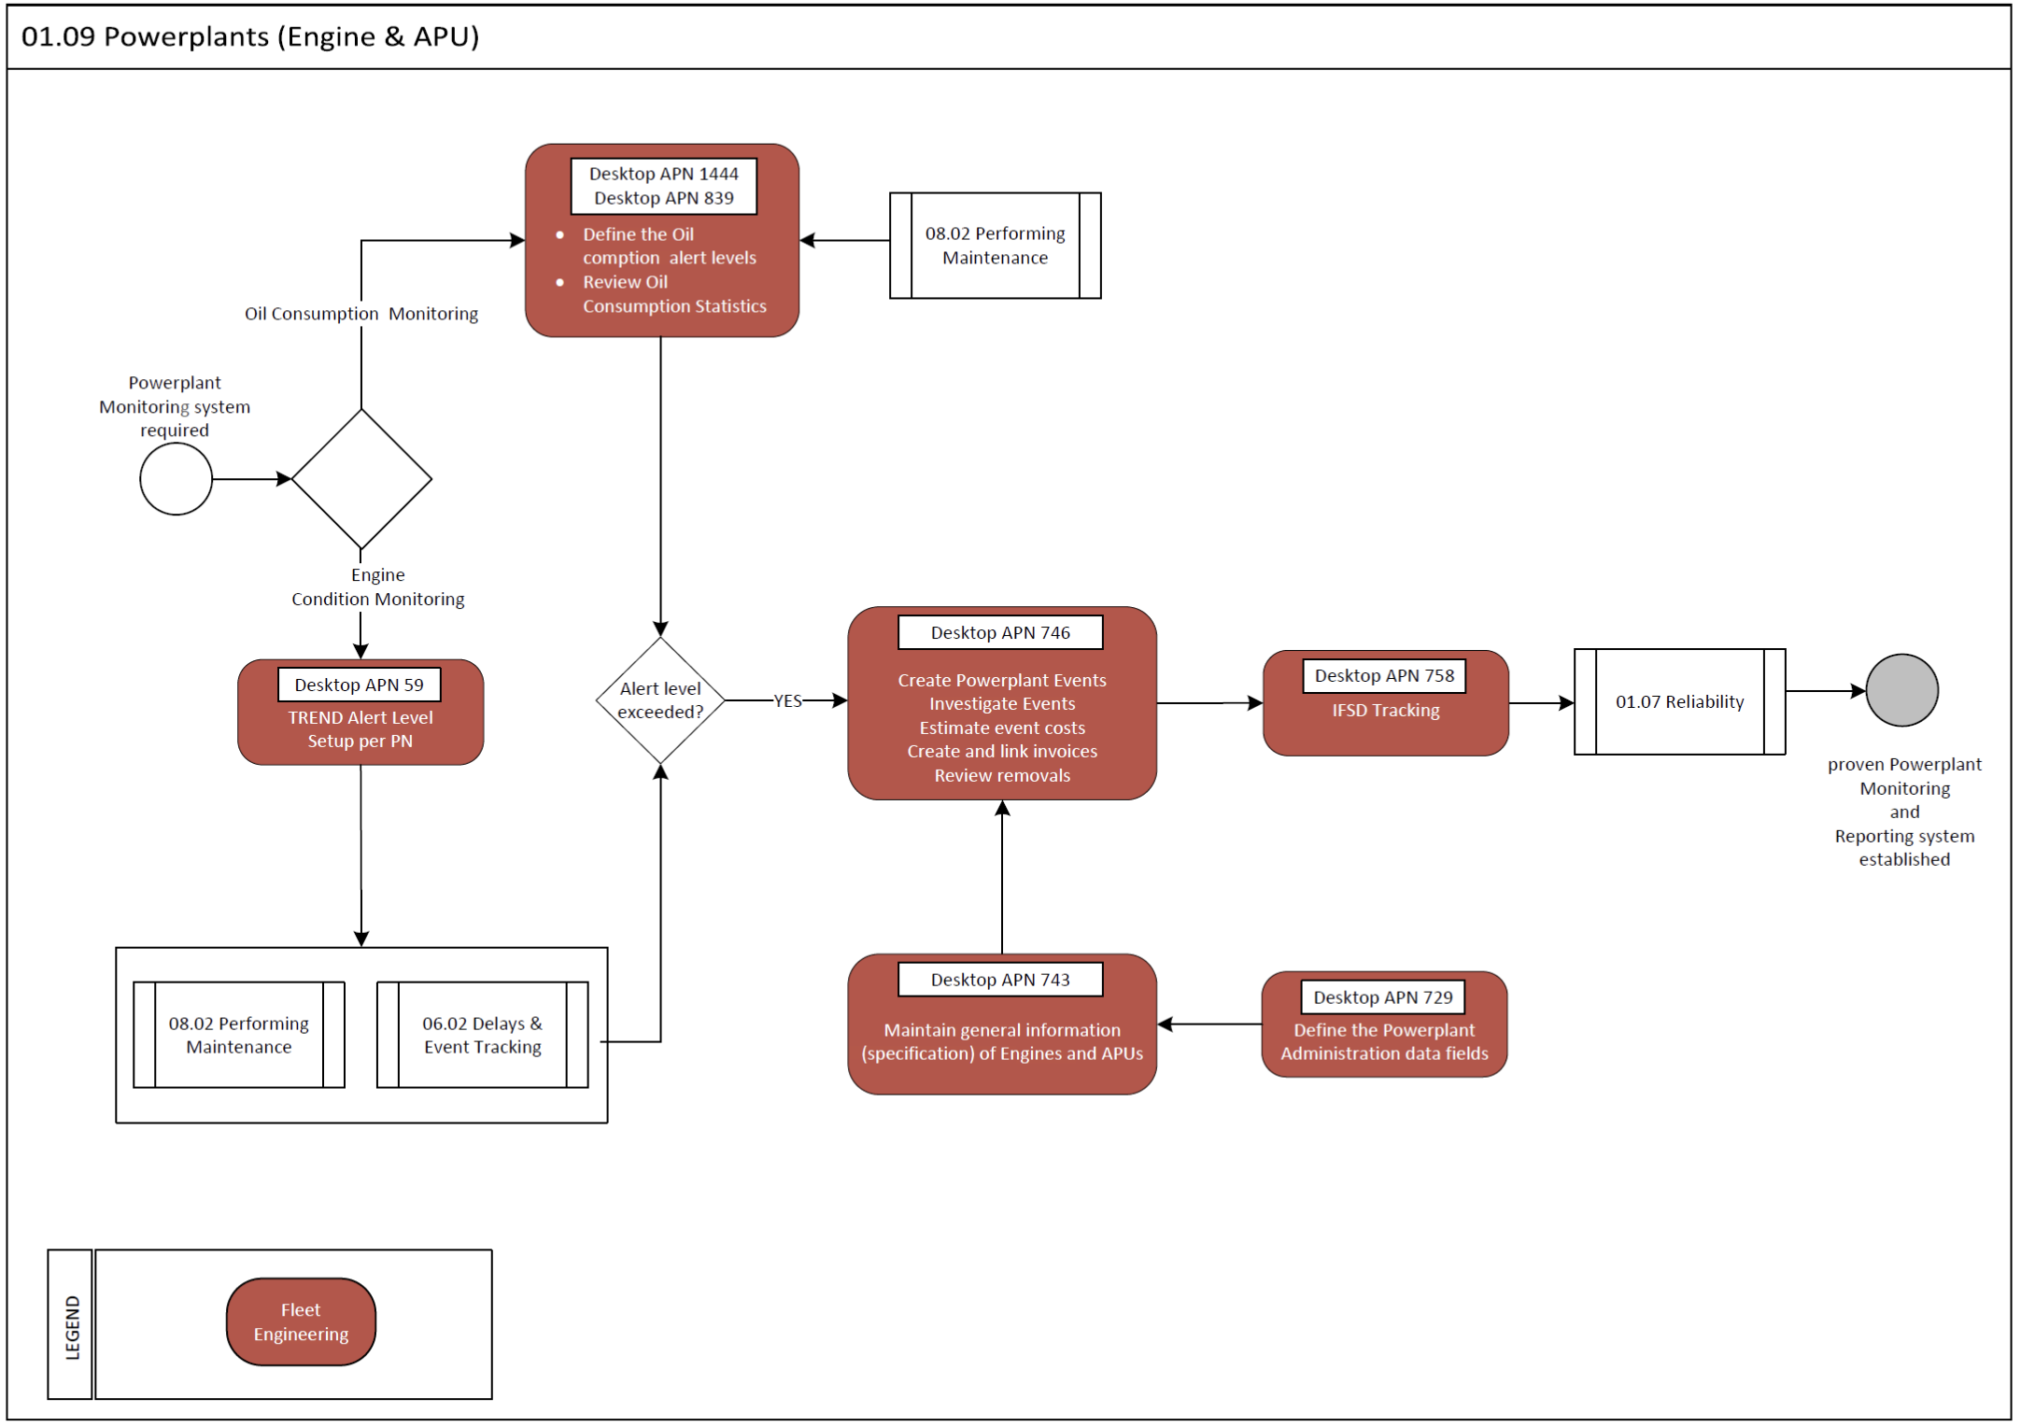

Process Design Questions

# | Question | Answer
Q1 | What are the duties of your engine department?
Q2 | Which reports do you use to control your engines?
Q3 | How do you control engine ratings?
Q4 | Who records IFSD?
Q5 | How is the Engine performance trend recorded and analyzed?
Q6 | How does your company control oil uplifts? Using the flight log or the technical logbook (workorder)
Q7 | Which are you alerts setup criteria?  Note: See options in Form Configuration “Oil Consumption Statistics”

Data (Source) Mapping

Data Sources | Description | Volume / Manual / Automatic / Static / Dynamic

Other Software Used

Other Softwares | Used by: | Description

AMOS Configuration

Basic Data

Basic Data Table | Notes
Limitation Type | The entries define the type of limitation or downgrade.
Powerplant Event Types | This table storing "Event Types" used by Powerplant Event modules.
Powerplant Removal Types | This table storing removal-codes used by Powerplant Event-Administration-Module.  The removal-types should be something like: BIRDSTRIKE, REPAIR, OVERHAUL, FOD, LOAN REMOVAL
Trend Type | Types of data trends used in Engine Condition Trend Monitoring to identify performance deterioration and malfunction of engine components and accessories.

Parameters

Parameter Code | Parameter Name | Notes
 | NIL

Workflows

Workflow Number | Workflow Name | Notes
27 | Oil Consumption Alert | This workflow is triggered after the oil consumption calculation job has finished and if there are some new or changed consumptions which exceed the configured thresholds. An email notification can be generated if configured.

API’s & Interfaces

Reference / Interface | Trigger
 | NIL

UAT Guidance

UAT No | Proposed User Acceptance Test Scenario

Annex – Additional Info

